Fancy Font Clock Hardware Assembly

General Info
This document covers the hardware used in the Fancy Font Clock, and its assembly. It is intended to help anyone who wants to build their own clock.

Parts List
- Case: The Fancy Font Clock case is available from:
Willd Designs & 3D Printing LLC
Will Dalziel
5819 E. US 190
Temple, TX 76501
254-677-6337
https://www.willddesigns.com/

You’ll need to contact Will for pricing/availability. You may need to remind Will that he produced 14 units in the summer of 2025.

- Raspberry Pi Zero 2 W with no GPIO header: Available from a number of sources, including Amazon (although cheaper sources may be available).

- Micro SD Card: At least 4GB in size, available from a number of sources, including Amazon (although cheaper sources may be available). Programmed with Raspberry Pi Imager per “Fancy Font Clock OS setup.txt” STEP 1.

- HDMI Display: The HDMI display is a 5.0 inch LCD, 800x480, HDMI, with PWM brightness control. I selected the Newhaven model NHD-5.0-HDMI-N-RTXL LCD module. Another LCD module could be used, but make sure it aligns with the mounting holes in the case, and check if it would require changes to the cables described here.

- HDMI Display Power Cable: DC power pigtail cable, 5.5mm x 2.1mm, 90 degree right angle DC barrel male plug jack connector to bare wire power. Available from Amazon (https://www.amazon.com/dp/B0851CV1Y6), and elsewhere. The overall cable length will need to be reduced to 4.8”.

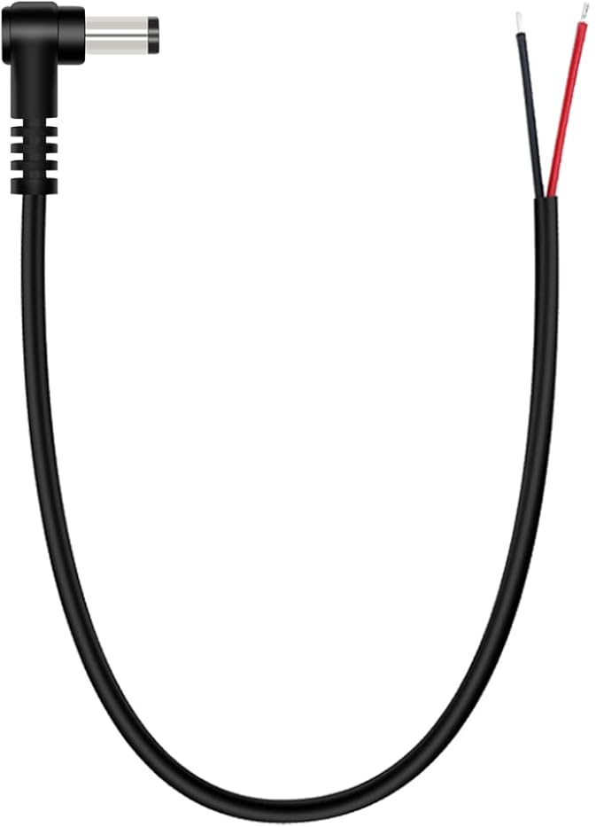

- HDMI Display Brightness Control Cable: 2-pin single head female jumper wire 2.54mm pitch connector length 30cm. Available from Amazon (https://www.amazon.com/dp/B0DN6TBYF9), and elsewhere. The cable length will need to be reduced to 5.8”.

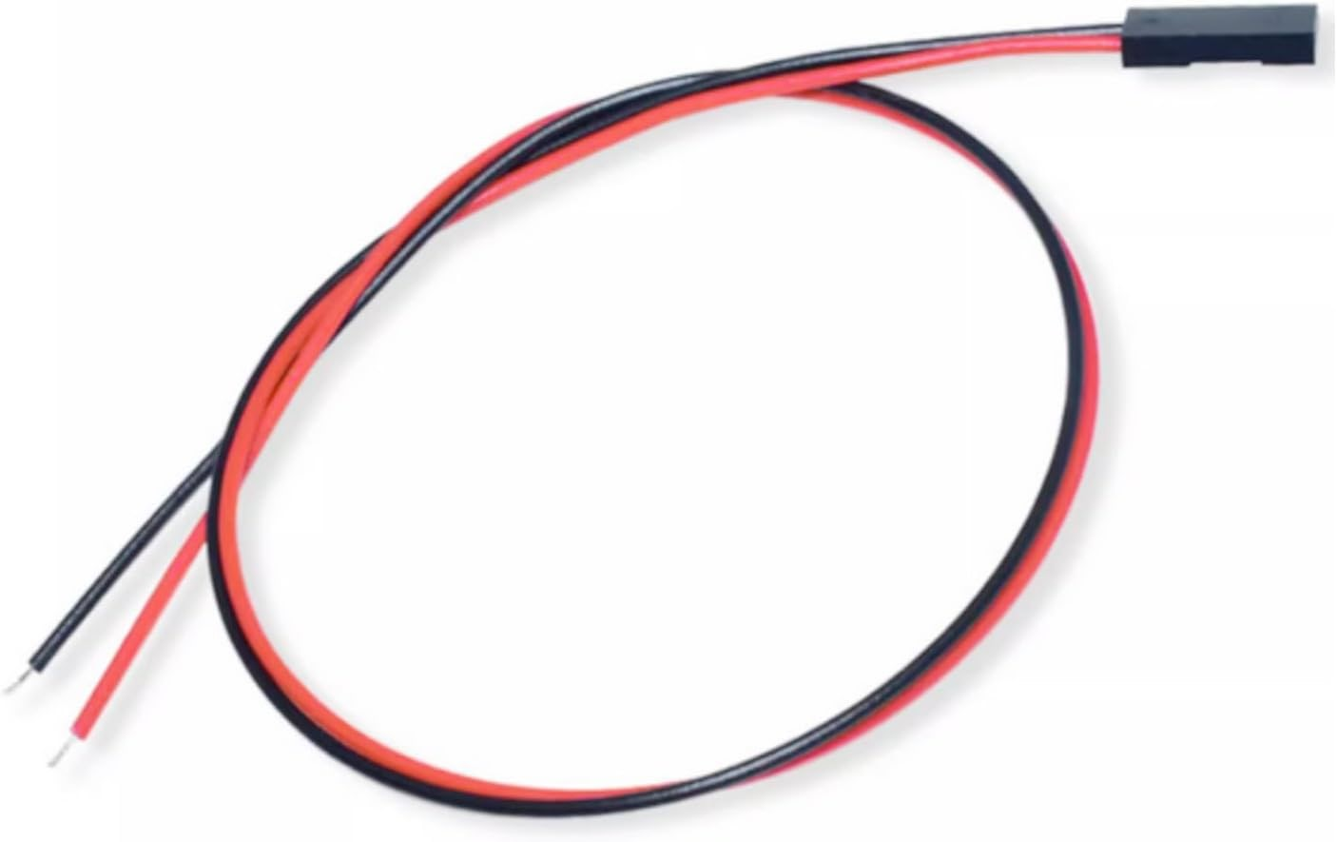

- HDMI Display Signal Cable: The HDMI signal cable is composed of three pieces:

  - A 20-pin, 0.5mm pitch, 0.3mm thick, 0.1m (10cm, 0.32ft) long flexible ribbon flat cable. Available from Amazon (https://www.amazon.com/dp/B07SLQWTVY), and elsewhere.

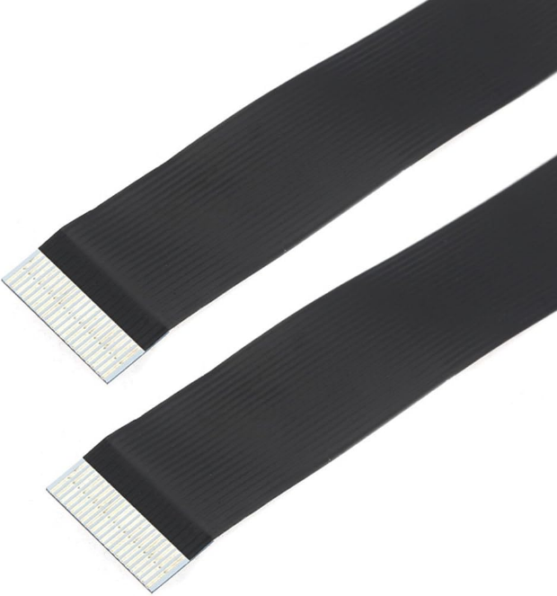

  - A 20-pin HDMI flat male 90 degree up angled connector for FPC ribbon cable. Available from Amazon (https://www.amazon.com/dp/B0C6MFXFMQ), and elsewhere.

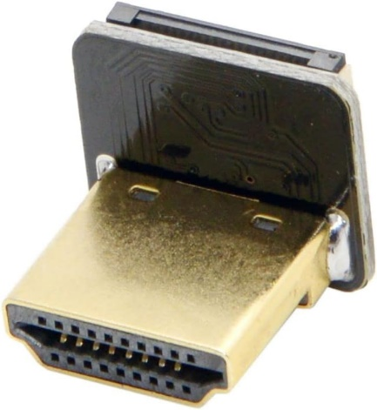

  - A 20-pin mini-HDMI flat male 90 degree up angled connector for FPC ribbon cable. Available from Amazon (https://www.amazon.com/dp/B01LYO44KM), and elsewhere.
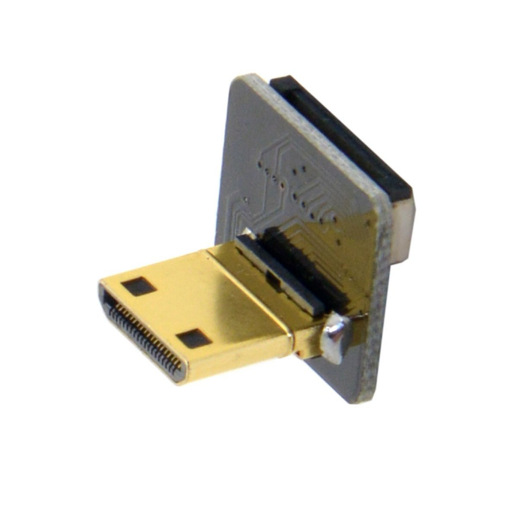
  - When assembled, the HDMI cable should appear as pictured below.

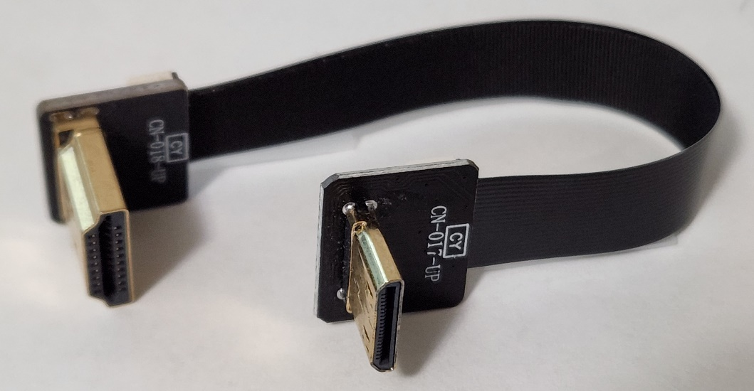

Fancy Font Clock Assembly
- There are any number of different screws that can be used to mount the Raspberry Pi and display to the case. Select the screws you intended to use, making sure the threads fit through the mounting holes in the Raspberry Pi and display, but the screw heads don’t. And the length isn’t too short to hold the Raspberry Pi and display in place, or too long for the mounting holes in the case. This may require two different screw sizes. Dry fit the screws to the case mounting holes intended. This may require using a drill or Dremel to enlarge the case mounting holes.

- Solder the HDMI power and brightness control cables to the Raspberry Pi GPIO holes as shown in the following diagram.

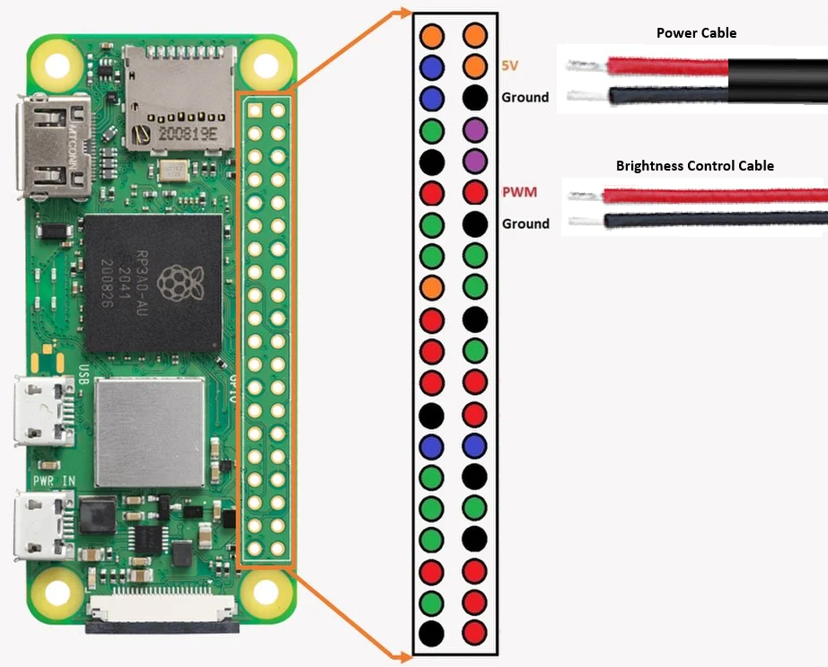

- Install the programmed micro SD card into the Raspberry Pi

- Connect the mini-HDMI connector of the HDMI signal cable to the Raspberry Pi.

- Install the Raspberry Pi into the case such that the two micro-USB connectors are accessible via the case’s rear opening.

- Position the HDMI display near the case and connect all three cables between the Raspberry Pi and display.

- Install the display into the case, routing the cables as pictured below.
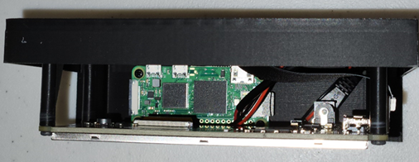
- Connect power and a USB keyboard to the clock using the micro-USB connectors that are accessible via the case’s rear opening.

- Turn on the power and complete the OS setup per the instructions found in “Fancy Font Clock OS setup.txt”

- Finish by installing the clock’s software per the instructions found in “Fancy Font Clock software install.txt”

Credits
Hardware/Software Engineer:
Paul Weber
Temple, TX

First Mechanical Engineer:
Jayben Scalph
Spokane Valley, WA

Second Mechanical Engineer and 3D Printing:
Will Dalziel
Willd Designs & 3D Printing LLC
5819 E. US 190
Temple, TX 76501
254-677-6337
https://www.willddesigns.com/

